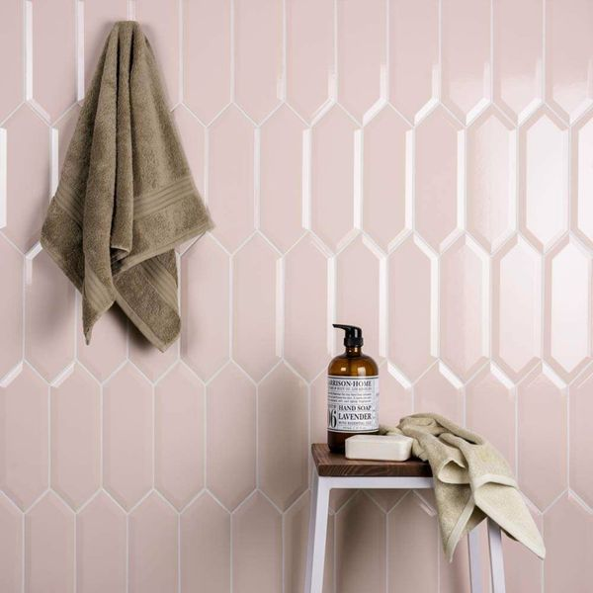**Bevelled Petal Pink Tiles:**

## **Product Description**

These Picket Bevelled Petal Pink Tiles have an elongated hexagonal design, with bevelled edges that add a definitive look, and makes the tiles 'pop' and stand out from the wall. They're made from ceramic, and can be used to transform the wall spaces in your bathroom, kitchen or hallway! Their shimmering gloss finish catches the eye!

**What's special about these tiles?**

> Hexagonal shape

> Definitive bevelled edge

> Shimmering gloss finish

> Long-lasting ceramic

## **Product Info**

* Product ID: 44239
* Tiles Per SQM: 40.00356024866
* Sale by: Per SQM
* Size: 300x100x8mm
* Weight: 0.36 KG
* Material Type: Ceramic
* Finish: Gloss
* Colour: Pink
* Suitability: Walls
* Rectified Edge: No
* Underfloor Heating: No
* Thickness (mm): 8